Incidents/accidents arising in the course of research
It is a requirement of ethics approval that researchers inform the Ethics Committee of any accidents, incidents or adverse events that arise during the course of research as soon as possible.
Such an incident might include an injury or accident resulting from the research, either to a person (who could be a participant, a member of the research team or a member of the public), a complaint or involve some other harm such as inadvertent release of personal data.

Researcher
If a complaint is received:
  - the researcher must contact the Research Ethics Manager immediately (Phone: 02 9739 2519 or ResEthics.Manager@acu.edu.au) with details of the complaint
  - where the researcher is a student, they must immediately inform their supervisor who should then contact the Research Ethics Manager
  - the Research Ethics Manager in conjunction with the HREC Chair and researcher will decide how best to respond to the complaint.
If an accidental release of data or breach of privacy occurs:
  - data should be recalled immediately where possible
  - where the researcher is a student, they must immediately inform their supervisor
  - the Research Ethics Manager (Phone: 02 9739 2519 or ResEthics.Manager@acu.edu.au) should be consulted and a plan of action determined.
If an incident/accident occurs, then the researcher must:
  - immediately deal with the situation to the best of their ability. For example, if someone is injured, then first aid should be rendered and assistance sought (e.g. Call an ambulance, take them to a doctor/clinic/hospital as appropriate)
  - where the researcher is a student, they must immediately inform their supervisor
  - the researcher should contact the Research Ethics Manager (Phone: 02 9739 2519 or ResEthics.Manager@acu.edu.au) with details of the incident
  - in the event of an injury, the researcher should complete a Riskware report on line in accordance with ACU’s Risk Management Policy and Procedure, and
    - nominate the Research Ethics Manager, Susanna Gorman (to view the incident (see below).
- Click on the Invite tab at the top of the report (see above) to view this tab (below) 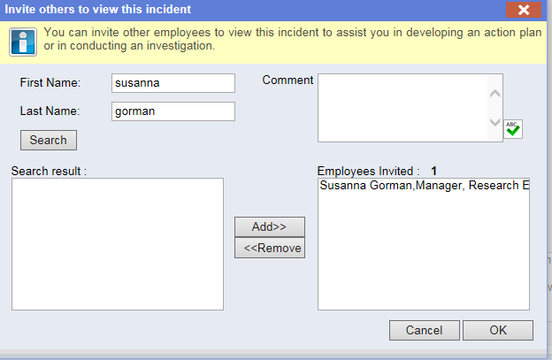

Research Ethics Manager
The Research Ethics Manager (REM) will review the report and determine:
  - the impact on the participant/or member of the research team
  - whether Finance needs to be informed for insurance purposes
  - whether Office of General Counsel needs to be informed
  - whether or not it may be necessary to suspend the protocol pending investigation
  - whether the injury/incident occurred as a result of a breach of approved protocol
  - if the incident occurred due to a breach of the approved protocol, in the first instance the Chair of the HREC should be informed and then the matter referred to the Pro Vice-Chancellor Research
  - where the incident was accidental and did not involve a deviation from the approved protocol, then the REM should in consultation with the Chair of the HREC and the researcher determine whether or not the research protocol requires a modification to prevent similar incidents occurring in future
  - a report should be prepared to be provided to the researcher’s line manager and relevant ADR/Institute Director, and to the PVCR
  - a report shall be provided to the next HREC meeting for the information of the Committee
  - the number and types of incidents will be reported to the University in the annual report.

